Molecular Modeling & Simulations
Practical No. 2
Plotting Potential Energy Curve / Surface

Name: Aakanksha Balode
Roll.no: 3
S.Y.MSc

Using the raw data provided, calculate the potential energy curve/ surface for ethane, butane and water. Save the plots in a word document. For each plot, identify all types of minima and maxima and explain why they are so.

Potential Energy Values for Ethane

Dihedral Angles | Potential Energy
0 | 4.39057
10 | 4.18971
20 | 3.64255
30 | 2.8989
40 | 2.15945
50 | 1.62068
60 | 1.424
70 | 1.62068
80 | 2.15945
90 | 2.8989
100 | 3.64255
110 | 4.1897
120 | 4.39057
130 | 4.1897
140 | 3.64255
150 | 2.89891
160 | 2.15945
170 | 1.62068
180 | 1.424
190 | 1.62068
200 | 2.15945
210 | 2.8989
220 | 3.64254
230 | 4.1897
240 | 4.39057
250 | 4.1897
260 | 3.64255
270 | 2.8989
280 | 2.15945
290 | 1.62068
300 | 1.424
310 | 1.62068
320 | 2.15945
330 | 2.8989
340 | 3.64255
350 | 4.1897
Potential Energy Curve for Ethane :

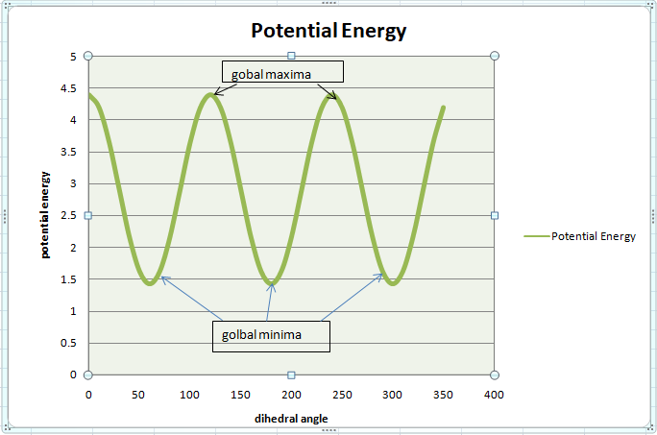

Global maxima =highest value
Global minima =Lowest value

- Potential Energy values for Butane:
Dihedral Angles | Potential energy
0 | 40.7825
37.92 | 38.2167
45.56 | 36.278
47.47 | 35.4317
57.75 | 34.6246
68.85 | 33.9607
79.9 | 33.2408
90.55 | 33.1581
101.14 | 33.5994
112.15 | 34.2352
123.3 | 34.2301
133.65 | 34.0298
142.59 | 33.0105
150.21 | 32.354
156.9 | 31.2952
163.04 | 30.0667
168.84 | 28.9387
174.46 | 28.1526
180 | 27.8716
185.54 | 28.1526
191.16 | 28.9387
196.96 | 30.0667
203.1 | 31.2952
209.79 | 32.354
217.41 | 33.0105
226.35 | 34.0298
236.7 | 34.2301
247.85 | 34.2352
258.86 | 33.5994
269.45 | 33.1581
280.1 | 33.2408
291.15 | 33.9607
302.25 | 34.6246
312.53 | 35.4317
314.44 | 36.278
322.08 | 38.2167

Potential Energy Curve for Butane:

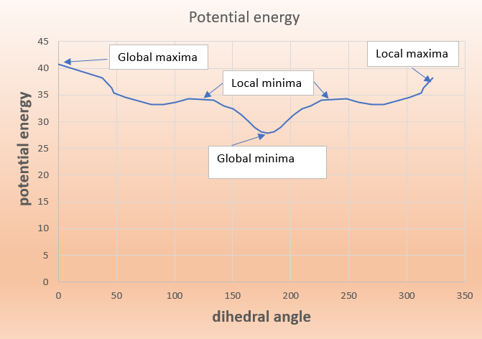
Global maxima =highest energy

Local maxima= near to global maxima

Global minima =Lowest energy

Local minima= near to global minima

- Potential Energy Values for Water
BA: Bond Angles
BL: Bond Lengths
BA  BL | 85 | 90 | 95 | 100 | 105 | 110 | 115 | 120 | 125
0.5 | 194.5124 | 191.6611 | 189.6473 | 188.471 | 188.1326 | 188.6319 | 189.9689 | 192.1437 | 195.1561
0.6 | 121.216 | 118.3646 | 116.3508 | 115.1747 | 114.8364 | 115.3357 | 116.6728 | 118.8474 | 121.8598
0.7 | 65.92042 | 63.0692 | 61.05541 | 59.87926 | 59.5409 | 60.04013 | 61.37713 | 63.55182 | 66.56407
0.8 | 28.62429 | 25.7728 | 23.75891 | 22.58277 | 22.24434 | 22.74358 | 24.0806 | 26.25528 | 29.26779
0.9 | 9.32842 | 6.47686 | 4.46303 | 3.28688 | 2.94845 | 3.44774 | 4.7847 | 6.95938 | 9.97175
1 | 8.03244 | 5.18091 | 3.16708 | 1.99096 | 1.65254 | 2.15179 | 3.48873 | 5.6634 | 8.67577
1.1 | 24.73648 | 21.88499 | 19.87114 | 18.69506 | 18.35664 | 18.85587 | 20.19281 | 22.36752 | 25.37987
1.2 | 59.44002 | 56.58857 | 54.57479 | 53.39882 | 53.0603 | 53.55969 | 54.89662 | 57.07137 | 60.08379
1.3 | 112.1444 | 109.2929 | 107.279 | 106.103 | 105.7645 | 106.264 | 107.6011 | 109.7757 | 112.7881

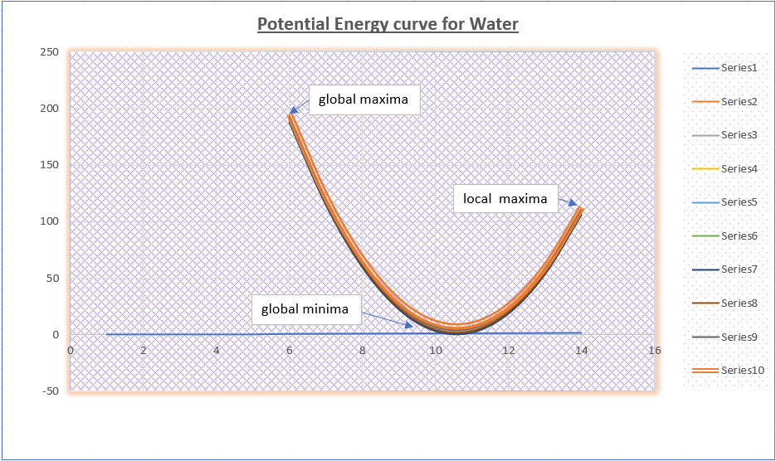
Global maxima =highest energy
Local maxima= near to global maxima
Global minima =Lowest energy.

